|  |  |  |  |  |
| --- | --- | --- | --- | --- |
|  |  | | |  |
|  |  | | |  |
|  | Comprehensive Status  <<Feature>> | | |  |
|  |  | | |  |
| Document Type | **Feature Document (FD)** | | |  |
| Template Version | **6.1b** | | |  |
| SysML Report Template Version | **O Beta (2021/06/09)** | | |  |
| Document ID | **ffst01.10_featuredocument_sysmlreporttemplate** | | |  |
| Document Location |  | | |  |
| Document Owner | **Sandeep Singh (ssing248), Joselyne McPhedran (jmcphed2)** | | |  |
| Document Revision | **A** | | |  |
| Document Status | **Approved** | | |  |
| Date Issued | **2021/07/30** | | |  |
| Date Revised | **2021/07/30** | | |  |
| Document Classification | GIS1 Item Number: | **27.60/35** | |  |
| GIS2 Classification: | **Confidential** | |
|  | | | | |
|  | | | | |
| Document Approval | | | | |
| Person | Role | | Email Confirmation | Date |
| Sandeep Singh | Feature Owner | | ssing248@ford.com | July 30, 2021 |
| Joselyne McPhedran | Feature Owner | | jmcphed2 @ford.com | July 30, 2021 |

**Auto-Generated by MagicDraw**

Printed Copies Are Uncontrolled

# Disclaimer

**This document contains Ford Motor Company Confidential information. Disclosure of the information contained in any portion of this document is not permitted without the expressed, written consent of a duly authorized representative of Ford Motor Company, Dearborn, Michigan, U.S.A.**

**Copyright, Ó 2021 Ford Motor Company**

This document contains information developed and accumulated by and for FORD MOTOR COMPANY. As such, it is a proprietary document, which, if disseminated to unauthorized persons, would provide others with restricted information, data, or procedures not otherwise available, exposing the FORD MOTOR COMPANY to potential harm.

Employees and suppliers having custody of this specification or authorized to use it must be cognizant of its proprietary nature and ensure that the information herein is not made available to unauthorized persons.

FORD MOTOR COMPANY reserves the right to protect this work as an unpublished copyrighted work in the event of an inadvertent or deliberate unauthorized publication. FORD MOTOR COMPANY also reserves its rights under copyright laws to protect this work as a published work.

This document or portions thereof shall not be distributed outside FORD MOTOR COMPANY without prior written consent. Refer all questions concerning disclosure to the author(s) or to any duly authorized representative of Ford Motor Company.

**Copyright** © **2021 Ford Motor Company**

# Contents

Disclaimer 2

Contents 3

1 Introduction 5

1.1 Document Purpose 5

1.2 Document Scope 5

1.3 Document Audience 5

1.3.1 Stakeholder List 5

1.4 Document Organization 6

1.4.1 Document Context 6

1.4.2 Document Structure 7

1.5 Document Conventions 7

1.5.1 Classification of Chapters 7

1.5.2 Requirements Templates 7

1.6 References 8

1.6.1 Ford Documents 8

1.6.2 External Documents and Publications 8

1.7 Glossary 8

1.7.1 Definitions 8

1.7.2 Abbreviations 8

1.7.3 Parameters / Values 8

2 Feature Overview 9

2.1 Purpose and Description of Feature 9

2.2 Feature Variants 9

2.2.1 Regions & Markets 10

2.3 Input Requirements/Documents 10

2.4 Lessons Learned 11

2.5 Assumptions 11

3 Feature Context 12

3.1 Feature Context Diagram 12

3.2 List of Influences 12

4 Feature Modeling 14

4.1 Operation Modes and States 14

4.2 Use Cases 19

4.2.1 Use Case Diagram 19

4.2.2 Actors 20

4.2.3 Use Case Descriptions 20

4.3 Driving and Operation Scenarios 22

4.4 Decision Tables 24

5 Feature Requirements 25

5.1 Functional Requirements 25

5.1.1 Error Handling 26

5.2 Non-Functional Requirements 26

5.2.1 Security 26

5.2.2 Reliability 26

5.2.3 Performance 27

5.3 HMI Requirements 27

5.4 Other Requirements 28

5.4.1 Design Requirements 28

5.4.2 Manufacturing Requirements 28

5.4.3 Service Requirements 28

5.4.4 After Sales Requirements 28

5.4.5 Process Requirements 28

6 Functional Safety 29

6.1 System Behaviors for HARA 29

6.2 Functional Safety Assumptions 29

6.3 Safety Goals 29

6.4 Functional Safety Requirements 29

6.4.1 Safety Goal: Prevent Hazard (Example) 29

6.4.2 Derivation of Functional Safety Requirements on Assumptions 32

6.4.3 ASIL Decomposition of Functional Safety Requirements 33

6.4.4 Decomposition of Functional Safety Requirement 33

7 CyberSecurity 34

7.1 Security Goals 34

7.2 Cybersecurity Requirements 34

8 Architecture 35

8.1 Functional Decomposition 35

8.1.1 Functions 38

8.2 Logical Architecture 38

8.2.1 Logical Elements 39

8.2.2 Logical Interfaces 40

9 Traceability Matrix 43

10 Open Concerns 45

11 Revision History 46

12 Appendix 47

12.1 Definitions 47

12.2 Abbreviations 47

**List of Figures**

Figure 2: Comprehensive Status Feature illustration 10

Figure 4: Comprehensive Status Context 13

Figure 5: Get ComStat at HMI Launch_Logical 15

Figure 5: Refresh ComStat from HMI_Logical 17

Figure 5: Update ComStat at Vehicle change event Alert_Logical 19

Figure 6: Feature Use Cases 21

Figure 7: W&RC #1 Diagram – Prevent Hazard (Example) 32

Figure 1. Prevent Hazard (Example) 32

Figure 8: Refresh Comprehensive Status from Offboard 37

Figure 8: Refresh Comprehensive status from Onboard 37

Figure 8: Retrieve latest available Comprehensive Status at HMI launch 38

Figure 9: Logical Architecture 40

**List of Tables**

Table 1: Features described in this FD 6

Table 4: Ford internal Documents 9

Table 6: External documents and publications 9

Table 8: Parameters / Values used in this document 9

Table 2: Feature Variants 11

Table 3: Regions & Markets 11

Table 2‑1: Input Requirements/Documents 12

Table 9: List of Influences 14

Table 10: Operation Modes and States on Get ComStat at HMI Launch_Logical 15

Table 11: Transitions between Operation Modes and States on Get ComStat at HMI Launch_Logical 16

Table 10: Operation Modes and States on Refresh ComStat from HMI_Logical 18

Table 11: Transitions between Operation Modes and States on Refresh ComStat from HMI_Logical 18

Table 10: Operation Modes and States on Update ComStat at Vehicle change event Alert_Logical 20

Table 11: Transitions between Operation Modes and States on Update ComStat at Vehicle change event Alert_Logical 20

Table 12: List of Actors 21

Table 13: System Behaviors for HARA 30

Table 15: Functional Safety Goals 30

Table 18: Cybersecurity Goals 35

Table 17: List of Functions on Refresh Comprehensive Status from Offboard 39

Table 17: List of Functions on Refresh Comprehensive status from Onboard 39

Table 17: List of Functions on Retrieve latest available Comprehensive Status at HMI launch 39

Table 19: Logical Elements 41

Table 18: Feature Interactions 43

Table 20: Open Concerns *(Not supported by MagicDraw report generation)* 46

Table 21: Definitions used in this document 48

Table 22: Abbreviations used in this document 48

# Introduction

## Document Purpose

A Feature Document (FD) document defines a Feature on [Concept Level](https://bd101001.pd2.ford.com/stages/#/workspace/209/_vv/(process/activity/_Y6ftAPI2VsW5zd82DgHb6g)). It specifies **what** the feature shall do and how it shall behave from customer perspective. It should also provide reasoning and background **why** we have the feature in the vehicle.

The FD also serves as an Item Definition as defined by ISO26262 for those features, which follow the Ford Functional Safety process. Refer [FFSG01.10 Feature Document Guideline](https://azureford.sharepoint.com/sites/GlobalFunctionalSafety/Released%20Templates%20Guidelines%20and%20Examples/Guidelines/FFSG01.10_FeatureDocument_Guideline.pdf) for how to apply the Feature Doc template for Functional Safety.

## Document Scope

This Feature Document describes the deployment of the feature Comprehensive Status to the following electrical architecture(s):

* FNV3 (Variant 1)

## Document Audience

The FD is written by the feature owner of Sandeep Singh (ssing248). All Stakeholders, i.e., all people who have a valid interest in the feature should read and, if possible, review the FD. It needs to be guaranteed, that all stakeholders have access to the currently valid version of the FD.

### Stakeholder List

For the latest list of stakeholder of the feature and their influence refer to <Put VSEM Link here>.

|  |  |  |  |
| --- | --- | --- | --- |
| **Name** | **CDSID** | **Role** | **Stakeholder Group** |
| Michael Zwickler | MZWICKLE | Development Engineer | Body Engineers |
| Matthew Duffy | MDUFFY35 | Cybersecurity Engineer | Cybersecurity Engineers |
| Sven Liebig | SLIEBIG | NetCom Engineer | NetCom Engineers |
| Simon Neill | SNEILL4 | ECG Appllication Engineer | Electrical Engineers (EESE) |
| Alex Tamburo | ATAMBUR2 | FP Strategy & Delivery | FordPass Engineers |
| Colin Drummond | CDRUMMO8 | Technical Expert | FordPass Engineers |
| Stephen O'shaughnessy | SOSHAUG1 | Body Closures Manager | Body Engineers |
| Siva Dhanalakota | SDHANAL6 | TCU Application Engineer | Electrical Engineers (EESE) |
| Warren Knight | WKNIGHT2 | Feature Owner Supervisor | Project Lead |
| Sercan Oezcan | SOEZCAN5 | Development Engineer | Electrical Engineers (EESE) |
| Raad Alhussainy | RALHUSSA | Feature Owner | Project Lead |
| Cameron Smyth | CSMYTH5 | Cybersecurity Architect | Cybersecurity Engineers |
| Joselyne McPhedran | JMCPHED2 | Feature Owner | Project Lead |
| Padma Priya Selvam | PSELVA12 | Solution Train Engineer | Project Lead |
| Sandeep Singh | SSING248 | Feature Owner | Project Lead |
| Ahmet Cinar | ACINAR1 | Technical Expert | Electrical Engineers (EESE) |
| Murali Chitturi | MCHITTUR | EC Platform Supervisor | Electrical Engineers (EESE) |
| Julien Bernasconi | JBERNAS1 | Model Architect | Systems Engineer |
| Melissa Morris | MMORR183 | SOA Software Analyst | Electrical Engineers (EESE) |
| Ian Pennington | IPENNING | Design Integrity Supervisor | Design Assurance |
| Jeffrey Hamel | JHAMEL7 | Technical Expert | FordPass Engineers |
| Denney Vellaramkalayil | DVELLARA | Technical Expert | Electrical Engineers (EESE) |
| Paritosh Gautam | PGAUTAM1 | Product Owner | Electrical Engineers (EESE) |
| Paul Bamford | PBAMFOR2 | BCM Application Engineer | Electrical Engineers (EESE) |
| Joel Castle | JCASTL19 | Design Integrity Engineer | Design Assurance |
| Oliver Gee | OGEE1 | Experience development Engineer | User Experience Engineers |
| Howard Middleton | HMIDDLE5 | BCM Application Engineer | Electrical Engineers (EESE) |
| Tom Tunstahl | TTUNSTA1 | Cybersecurity Engineer | Cybersecurity Engineers |
| Vibha Ravindra | VRAVIND4 | Functional Safety Engineer | FuSa Engineers |
| Beatrice Fusier | BFUSIER | Feature Delivery Leader | Project Lead |

## Document Organization

### Document Context

Refer to the [Specification Structure page](http://wiki.ford.com/display/RequirementsEngineering/Specification+templates) in the [Ford RE Wiki](http://wiki.ford.com/display/RequirementsEngineering/Requirements+Engineering+for+SW+Enabled+Features) to understand how the FD relates to other Ford Requirements Documents and Specifications.

### Document Structure

The structure of this document is explained below:

**Introduction** – Explains how to use this document including responsibilities and requisite documents. Explains the terminology. Gives a clarification of the definitions, concepts and abbreviations used in the document.

**Feature Overview** – States briefly the background and the purpose of the feature, feature variants and corresponding regions and markets. Also includes input requirements, assumptions and constraints.

**Feature Context** – describes all external entities, which have an influence on the feature.

**Feature Modeling** – Contains Use Case, Driving Scenarios, State Charts to describe the functional behavior of the feature.

**Feature Requirements** – Lists functional and non-functional requirements of the feature.

**Functional Safety** – Lists System Behaviors, Safety Goals and Safety Requirements of the feature.

**Cybersecurity** – Lists Security Goals and Security Requirements of the feature.

**Architecture** – Shows the coarse architecture, which the feature requirements are deployed to. Describes the elements and the boundary of the feature as well as the decomposition and distribution of associated functions.

**Traceability Matrix** – Traceability Matrix.

**Open Concerns** – List of Open Concerns

**Revision History** – Document Change History including a list of new or modified requirements. The requirements in this document are tagged, and this section contains different types of tables listing all, new, or changed requirements by their title and page no.

**Appendix** – Appendix

## Document Conventions

### Classification of Chapters

A chapter is considered mandatory, unless the chapter or its parent chapter(s) are categorized by using the tag:

**#Classification:** Some Condition

If no requirement/other content is known for a mandatory chapter, leave a statement “Not Applicable”

Some chapters have a follow certain rules in context of specific Ford processes, e.g. Functional Safety. This is indicated at the beginning of the corresponding chapter by the tags:

**#Functional Safety:** Some process specific explanation

**#Cybersecurity:** Some process specific explanation

### Requirements Templates

Refer to “[How to use the Specification Templates](http://wiki.ford.com/display/RequirementsEngineering/How+to+use+the+Specification+Templates?src=contextnavpagetreemode)” on how to use the specification templates and the VBA macros to create/edit the requirements in the specifications.

#### **Requirements Attributes**

The templates provided by *Specification_Macros.dotm* define a list of attributes for each requirement. This helps to classify the requirement. The attributes are explained at [RE Wiki - Requirements Attributes](http://wiki.ford.com/display/RequirementsEngineering/Requirements+Attributes?src=contextnavpagetreemode).

## References

### Ford Documents

List here all Ford internal documents, which are directly related to the feature.

| **Reference** | **Title** | **Doc. ID** | **Document Location** | **Revision** |
| --- | --- | --- | --- | --- |
| Ford GIS Standard | Ford GIS Standard |  |  |  |

Table 4: Ford internal Documents

### External Documents and Publications

The list of external documents could include books, reports and online sources.

| **Reference** | **Document / Publication** | **Document Location** |
| --- | --- | --- |
| IEEE Std 1012-2004 IEEE Standard for Software Verification and Validation |  |  |
| ISO/IEC 19500-2:2003 | Information technology -- Open Distributed Processing -- Part 2 |  |
| UML Testing Profile (UTP), v1.2 |  |  |
| Wikipedia |  |  |

Table 6: External documents and publications

## Glossary

### Definitions

| **Definition** | **Description** |
| --- | --- |
| API | Application Program Interface |
| ATT | Advanced Transport Telematics |
| BCM | Body Control Module |
| BEC | Back Enclosure |
| CAN | Controller Area Network |
| CCS | Customer Connectivity Setting |
| ComStat | Comprehensive Status |
| ComStat feat. | Comprehensive Status feature |
| DFMEA | Design - Failure Modes and Effects Analysis |
| DRX | Discontinuous Reception |
| ECG | Enhanced Central Gateway |
| EDS | Electrical Distribution System |
| FMA | Failure Modes Analysis |
| FTCP | Ford Telematics Communication Protocol |
| IoT | Internet of Things |
| LIN | Local Interconnect Network |
| MQTT | Message Queuing Telemetry Transport |
| SoC | State of Charge |
| TCU | Telematics Control Unit |
| TMC | Transport Mobility Cloud |
| VSDN | Vehicle Service Delivery Network |

### Abbreviations

### Parameters / Values

| **Name** | **Description** | **Range / Resolution** |
| --- | --- | --- |

Table 8: Parameters / Values used in this document

# Feature Overview

## Purpose and Description of Feature

**Variant 1:** The comprehensive status feature will allow the user to check the real door lock status, and ajar status of the vehicle via the FordPass App.

**Variant 2:** The comprehensive status feature will allow the user to check the door lock status (real/ inferred), ajar status, and window status of the vehicle via the FordPass App.

## Feature Variants

|  |  |  |
| --- | --- | --- |
| **Variant Name** | **Variant Description** | **Remarks** |
| **1** | The comprehensive status feature will allow the user to check the real door lock status, and ajar status of the vehicle via the FordPass App. |  |
| **2** | The comprehensive status feature will allow the user to check the door lock status (real/ inferred), ajar status, and window status of the vehicle via the FordPass App. |  |

Table 2: Feature Variants

### Regions & Markets

|  |  |  |  |  |  |  |
| --- | --- | --- | --- | --- | --- | --- |
| **Market /**  **Region**  Variant Name | **North America** | **South America** | **Europe** | **Middle East/Africa** | **Asia / Pacific** | **China** |
| **V1** | Optional | Optional | Optional | Optional | Optional | Optional |
| **V2** | Optional | Optional | Optional | Optional | Optional | Optional |

Table 3: Regions & Markets

## Input Requirements/Documents

|  |  |  |  |
| --- | --- | --- | --- |
| **Reference**  (Reference as listed in ch. “References”) | **Section/Requirement** | **Description** | **Derived Requirement**  (optional – reference to requirement in ch. “Feature Implementation Requirements”) |
| **Feature/Function Requirements** | | | |
| [VSEM Rich Client](https://www.vsemweb.ford.com/tc/launchapp?-attach=true&-s=226TCSession&-o=HMoBIwL5x3NrTD%0d), [VSEM Active Workspace](https://www.vsemawc.ford.com/awc/#/com.siemens.splm.clientfx.tcui.xrt.showObject?uid=HMoBIwL5x3NrTD ) | Enclosure Service Specification | Platform Vehicle Control Service Specification | REQ-409630  REQ-409632  REQ-422269  REQ-422270  REQ-422271  REQ-422273 |
|  |  |  |  |
| **Ford Engineering Standards** | | | |
|  |  |  |  |
|  |  |  |  |
| **Legal Regulations** | | | |
|  | Compliance with FMVSS101 | The Feature shall comply with FMVSS101. |  |
|  |  |  |  |
| **Industry Standards** | | | |
|  | ISO 26262 | The system should be developed according to Ford's implementation of Functional Safety. |  |
|  |  |  |  |
| **Other Sources** | | | |
|  |  |  |  |
|  |  |  |  |
|  |  |  |  |

Table 2‑1: Input Requirements/Documents

## Lessons Learned

No lessons learned specified.

## Assumptions

No Assumptions specified.

# Feature Context

## Feature Context Diagram

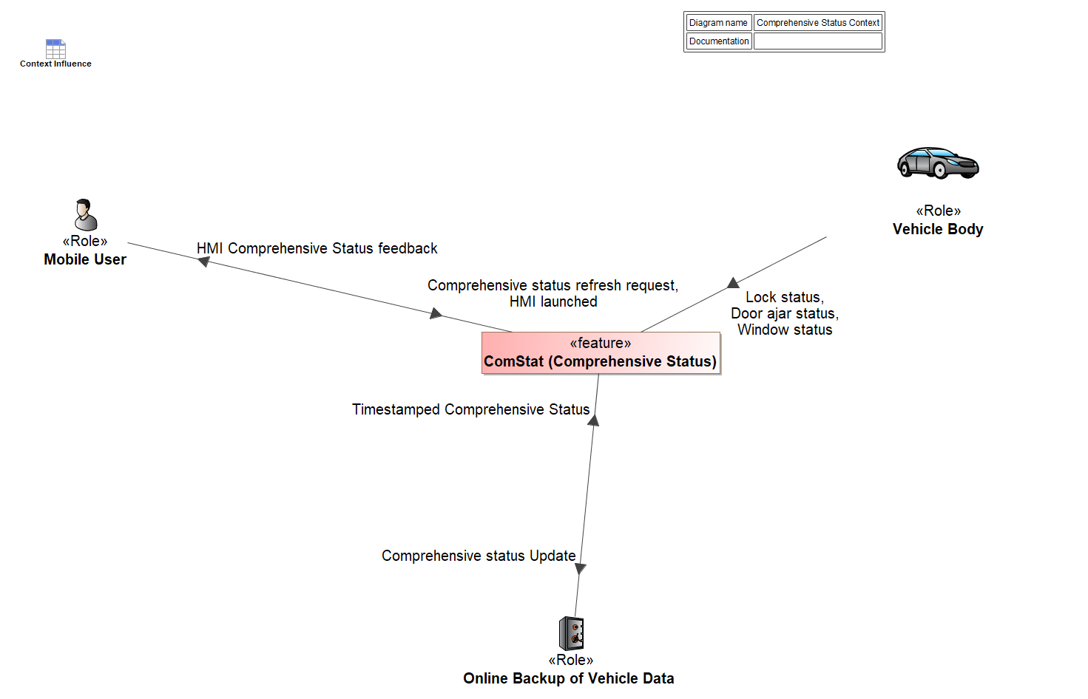

Figure 4: Comprehensive Status Context

## List of Influences

|  |  |  |
| --- | --- | --- |
| **ID** | **External Entity** | **Influence Description** |
| Comprehensive status Update | ComStat (Comprehensive Status) To Online Backup of Vehicle Data | Update of Comprehensive Status online |
| Comprehensive status refresh request | Mobile User To ComStat (Comprehensive Status) | Refresh request on Mobile App |
| Door ajar status | Vehicle Body To ComStat (Comprehensive Status) | Door ajar status of all doors |
| HMI Comprehensive Status feedback | ComStat (Comprehensive Status) To Mobile User | Comprehensive Status made of Door ajar and lock status for all variants and window status only for variant 2 displayed on the mobile device |
| HMI launched | Mobile User To ComStat (Comprehensive Status) | Related to the launch of the Mobile App |
| Lock status | Vehicle Body To ComStat (Comprehensive Status) | Lock status of all doors |
| Timestamped Comprehensive Status | Mobile User To ComStat (Comprehensive Status) | Latest available comprehensive status is timestamped online from the date it retrieved the data from the vehicle |
| Online Backup of Vehicle Data To ComStat (Comprehensive Status) | Latest available comprehensive status is timestamped online from the date it retrieved the data from the vehicle |
| Window status | Vehicle Body To ComStat (Comprehensive Status) | Window status, only available for the variant 2 of the feature |

Table 9: List of Influences

# Feature Modeling

## Operation Modes and States

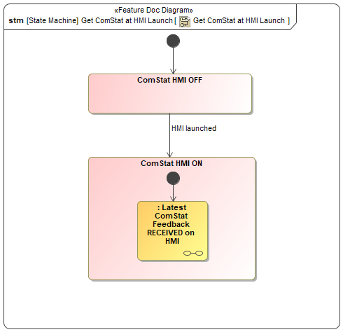

Figure 2: Get ComStat at HMI Launch Part I_Logical

|  |  |  |
| --- | --- | --- |
| **State** | **Description** | **Requirements Reference** (optional) |
| ComStat HMI OFF | HMI is not yet launched |  |
| ComStat HMI ON | HMI is ON |  |
| Latest ComStat Feedback RECEIVED on HMI | Latest refreshed Comprehensive Status is displayed with Time stamp on HMI |  |

Table 8: Operation Modes and States on Get ComStat at HMI Launch_Logical

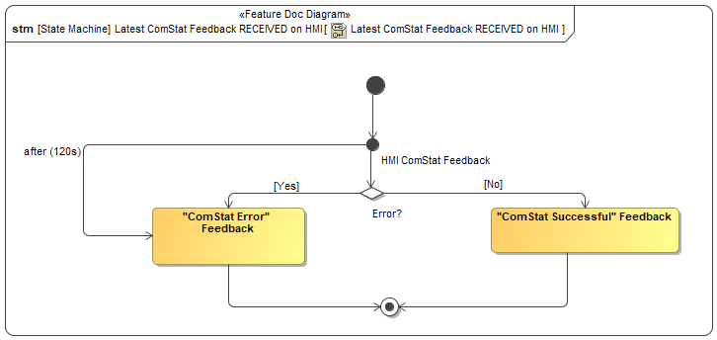

|  |  |  |
| --- | --- | --- |
| **State** | **Description** | **Requirements Reference** (optional) |
| ComStat Error Feedback | Error notification feedback displayed on HMI after a time-out duration of 120s or if the Comprehensive Status has not been fully retrieved from the Cloud. |  |
| ComStat HMI ON | Successful feedback displayed on HMI if a complete Comprehensive Status has been fully retrieved from the Cloud. |  |

Table 9: Operation Modes and States on Get ComStat at HMI Launch Part II_Logical

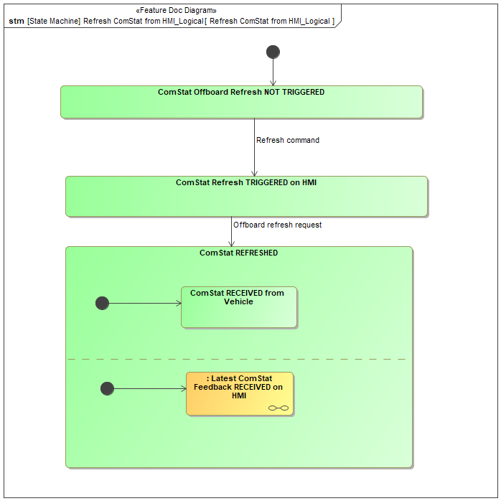

Figure 3: Refresh ComStat from HMI_Logical

|  |  |  |
| --- | --- | --- |
| **State** | **Description** | **Requirements Reference** (optional) |
| ComStat Offboard Refresh NOT TRIGGERED | Comprehensive Status refresh not triggered |  |
| ComStat Refresh TRIGGERED on HMI | Comprehensive Status refresh triggered as user perform refresh action on HMI |  |
| ComStat REFRESHED | Latest refreshed comprehensive Status is stored on Cloud as well as it is received on HMI |  |
| ComStat RECEIVED from Vehicle | Comprehensive Status received on Cloud from Vehicle |  |
| Latest ComStat Feedback RECEIVED on HMI | Latest refreshed Comprehensive Status is displayed with Time stamp on HMI |  |

Table 10: Operation Modes and States on Refresh ComStat from HMI_Logical

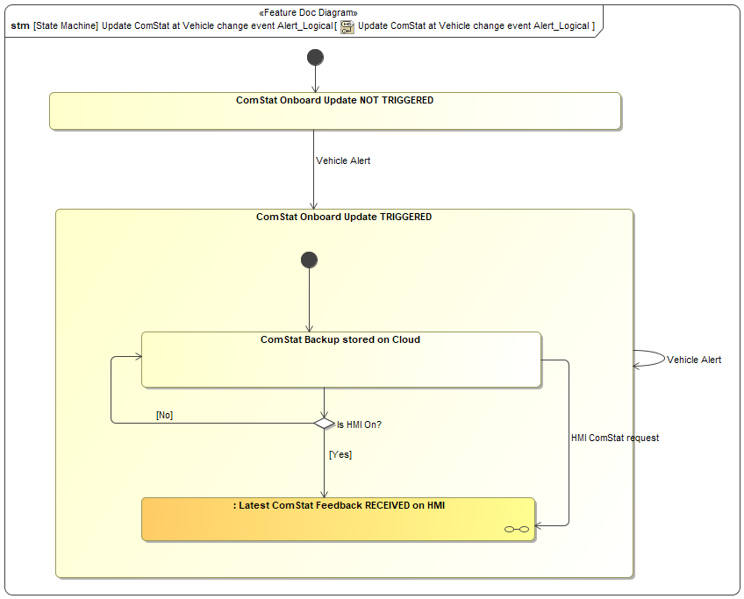

Figure 4: Update ComStat at Vehicle change event Alert_Logical

|  |  |  |
| --- | --- | --- |
| **State** | **Description** | **Requirements Reference** (optional) |
| ComStat Onboard Update NOT TRIGGERED | Comprehensive Status refresh is not yet triggered from Onboard. |  |
| ComStat Onboard Update TRIGGERED | Comprehensive Status refresh triggered from Onboard |  |
| ComStat Backup stored on Cloud | Latest Comprehensive Status is stored online. |  |
| Latest ComStat Feedback RECEIVED on HMI | Latest refreshed Comprehensive Status is displayed with Time stamp on HMI |  |

Table 11: Operation Modes and States on Update ComStat at Vehicle change event Alert_Logical

## Use Cases

### Use Case Diagram

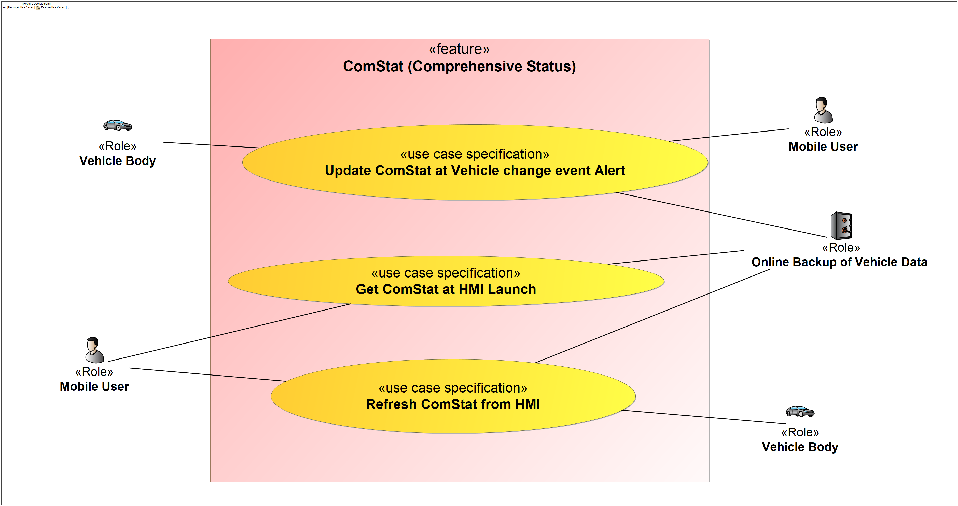

Figure 5: Feature Use Cases

### Actors

| **Actor** | **Description** |
| --- | --- |
| Mobile User | Customer using a mobile device |
| Online Backup of Vehicle Data | Online backup of the comprehensive status data |
| Vehicle Body | The part of the vehicle of interest for the feature |

Table 12: List of Actors

### Use Case Descriptions

Update ComStat at Vehicle change event Alert

|  |  |  |
| --- | --- | --- |
| **Actors** | Primary | Vehicle Body |
| Secondary | Online Backup of Vehicle Data  Mobile User |
| **Subject** |  | ComStat (Comprehensive Status) |
| **Description** |  |  |
| **Preconditions** |  |  |
| **Triggers** | T1 | Door lock or ajar status |
| **Main Flow Description** |  | -Door lock or ajar status change  -Update of ComStat on the Cloud  -Updated ComStat pushed to HMI if HMI is On |
| **Postconditions** | PostC1 | ComStat updated on the Cloud |
| PostC2 | ComStat refreshed on HMI |

Get ComStat at HMI Launch

|  |  |  |
| --- | --- | --- |
| **Actors** | Primary | Mobile User |
| Secondary | Online Backup of Vehicle Data |
| **Subject** |  | ComStat (Comprehensive Status) |
| **Description** |  |  |
| **Preconditions** |  |  |
| **Triggers** | T1 | Mobile User launches HMI |
| **Main Flow Description** |  | -Mobile User launches HMI  -ComStat feature retrieves the latest timestamped ComStat from the Cloud |
| **Postconditions** | PostC1 | ComStat displayed on HMI based on latest data from the Cloud |

Refresh ComStat from HMI

|  |  |  |
| --- | --- | --- |
| **Actors** | Primary | Mobile User |
| Secondary | Vehicle Body |
| **Subject** |  | ComStat (Comprehensive Status) |
| **Description** |  |  |
| **Preconditions** | PreC1 |  |
| **Triggers** | T1 | Mobile user refresh on HMI |
| **Main Flow Description** |  | -Mobile user performs refresh action on HMI  -Vehicle provides ComStat to the Cloud  -ComStat feature retrieves the latest timestamped ComStat from the Cloud |
| **Postconditions** | PostC1 | Comprehensive Status refreshed on HMI |

## Driving and Operation Scenarios

Update ComStat at Vehicle change event Alert

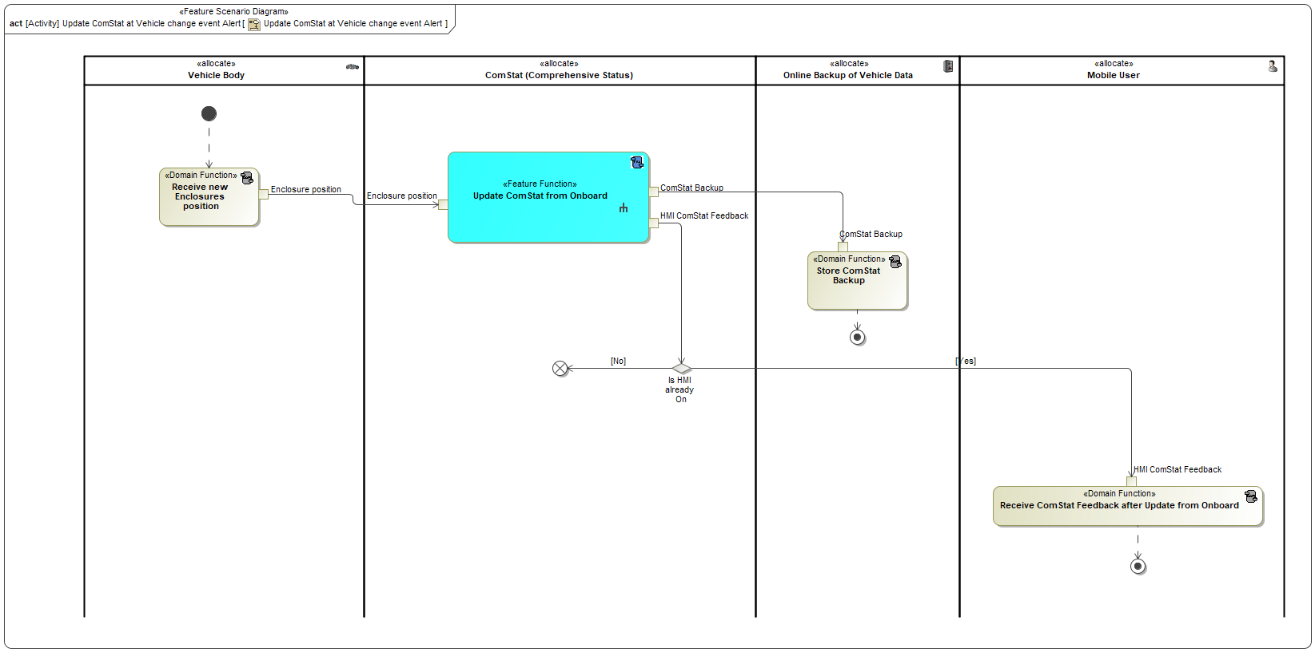

Get ComStat at HMI Launch

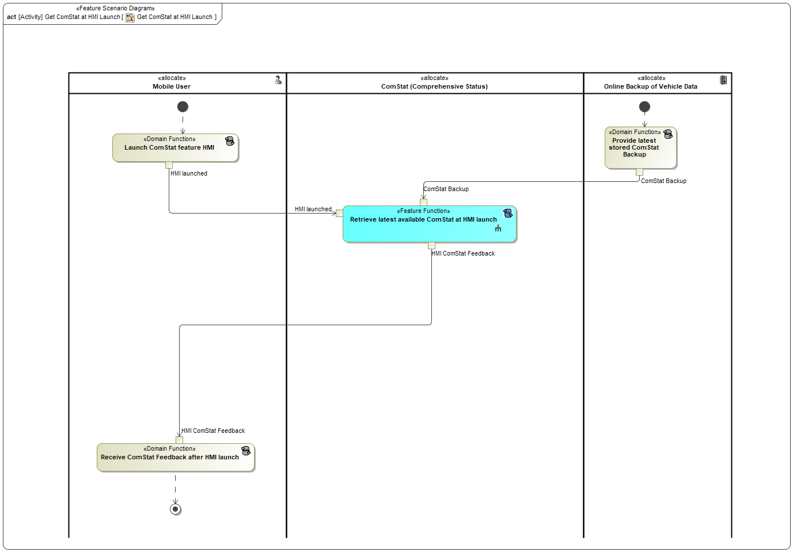

Refresh ComStat from HMI

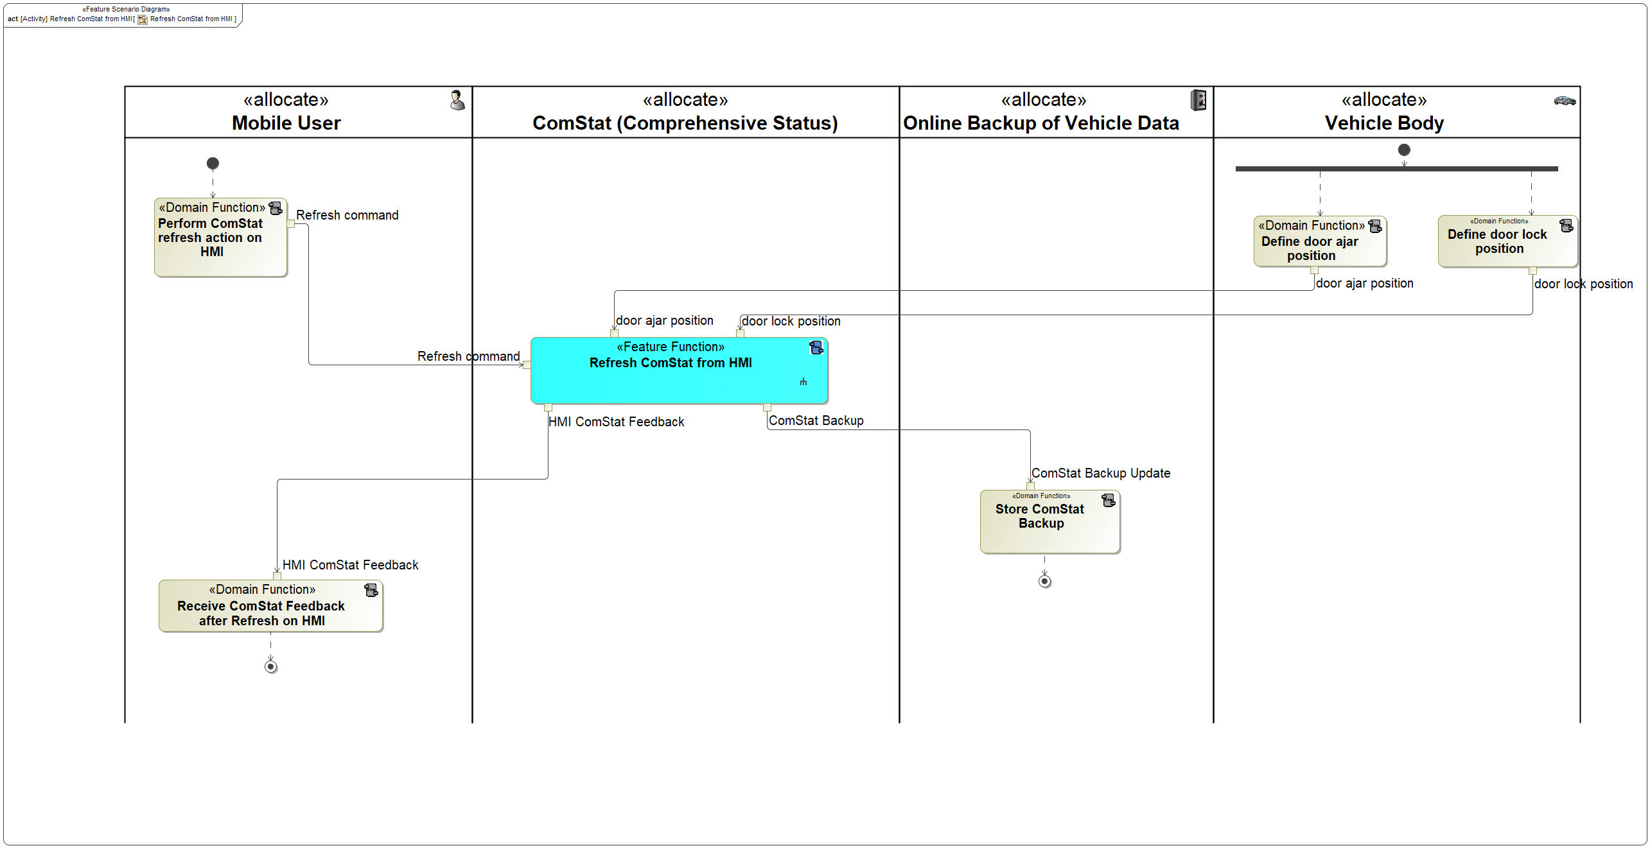

# Feature Requirements

## Functional Requirements

FR#1-Feature Door Status Onboard Capability

ComStat feature shall be able to provide door locking and ajar status as part of comprehensive status

|  |  |  |  |  |  |  |  |
| --- | --- | --- | --- | --- | --- | --- | --- |
| Requirement ID: | | | | | | | |
| **Rationale** |  | | | | | | |
| **Acceptance Criteria** | Cloud receives door lock and ajar status from Vehicle | | | | | | |
| **Notes** |  | | | | | | |
| **Source** |  | | | | | **Owner** |  |
| **Source Req.** |  | | | | | **V&V Method** |  |
| **Type** |  | | | **Priority** |  | **Status** | In-Progress |
| [Req. Template](http://wiki.ford.com/display/RequirementsEngineering/Requirements+Attributes) Version | | 6.0 | End of Requirement | | | | |

FR#2-Feature Door Status Logic

Feature shall only report door status as locked when door is closed and locked

|  |  |  |  |  |  |  |  |
| --- | --- | --- | --- | --- | --- | --- | --- |
| Requirement ID: | | | | | | | |
| **Rationale** |  | | | | | | |
| **Acceptance Criteria** |  | | | | | | |
| **Notes** |  | | | | | | |
| **Source** |  | | | | | **Owner** |  |
| **Source Req.** |  | | | | | **V&V Method** |  |
| **Type** |  | | | **Priority** |  | **Status** | In-Progress |
| [Req. Template](http://wiki.ford.com/display/RequirementsEngineering/Requirements+Attributes) Version | | 6.0 | End of Requirement | | | | |

FR#3-ComStat Update In-Vehicle trigger

When door status changes onboard, it shall be updated and stored on the Cloud.

|  |  |  |  |  |  |  |  |
| --- | --- | --- | --- | --- | --- | --- | --- |
| Requirement ID: | | | | | | | |
| **Rationale** |  | | | | | | |
| **Acceptance Criteria** |  | | | | | | |
| **Notes** |  | | | | | | |
| **Source** |  | | | | | **Owner** |  |
| **Source Req.** |  | | | | | **V&V Method** |  |
| **Type** |  | | | **Priority** |  | **Status** | In-Progress |
| [Req. Template](http://wiki.ford.com/display/RequirementsEngineering/Requirements+Attributes) Version | | 6.0 | End of Requirement | | | | |

FR#4-ComStat Refresh Offboard trigger

When mobile user performs a refresh action on HMI, the latest Door status shall be retrieved from the vehicle and displayed on the HMI.

|  |  |  |  |  |  |  |  |
| --- | --- | --- | --- | --- | --- | --- | --- |
| Requirement ID: | | | | | | | |
| **Rationale** |  | | | | | | |
| **Acceptance Criteria** |  | | | | | | |
| **Notes** |  | | | | | | |
| **Source** |  | | | | | **Owner** |  |
| **Source Req.** |  | | | | | **V&V Method** |  |
| **Type** |  | | | **Priority** |  | **Status** | In-Progress |
| [Req. Template](http://wiki.ford.com/display/RequirementsEngineering/Requirements+Attributes) Version | | 6.0 | End of Requirement | | | | |

FR#5-ComStat Refresh after Update

When door status is updated on the Cloud and HMI is On, door status shall be pushed to HMI.

|  |  |  |  |  |  |  |  |
| --- | --- | --- | --- | --- | --- | --- | --- |
| Requirement ID: | | | | | | | |
| **Rationale** |  | | | | | | |
| **Acceptance Criteria** |  | | | | | | |
| **Notes** |  | | | | | | |
| **Source** |  | | | | | **Owner** |  |
| **Source Req.** |  | | | | | **V&V Method** |  |
| **Type** |  | | | **Priority** |  | **Status** | In-Progress |
| [Req. Template](http://wiki.ford.com/display/RequirementsEngineering/Requirements+Attributes) Version | | 6.0 | End of Requirement | | | | |

### Error Handling

EHR#1-ComStat Timeout

The user shall be notified with an error feedback message if the Comprehensive status cannot be retrieved within 120s.

|  |  |  |  |  |  |  |  |
| --- | --- | --- | --- | --- | --- | --- | --- |
| Requirement ID: | | | | | | | |
| **Rationale** | Provide error feedback | | | | | | |
| **Acceptance Criteria** | Error notification appears "unable to retrieve door status information" | | | | | | |
| **Notes** |  | | | | | | |
| **Source** |  | | | | | **Owner** |  |
| **Source Req.** |  | | | | | **V&V Method** | PDP.9.2 Prototype vehicle Test PDP.9.1 In-vehicle Test PDP.7.3 MIL Function Test |
| **Type** |  | | | **Priority** |  | **Status** | In-Progress |
| [Req. Template](http://wiki.ford.com/display/RequirementsEngineering/Requirements+Attributes) Version | | 6.0 | End of Requirement | | | | |

## Non-Functional Requirements

### Security

NFR#1-Feature Subscription

For retail user, Comprehensive Status feature shall not require a subscription

|  |  |  |  |  |  |  |  |
| --- | --- | --- | --- | --- | --- | --- | --- |
| Requirement ID: | | | | | | | |
| **Rationale** |  | | | | | | |
| **Acceptance Criteria** |  | | | | | | |
| **Notes** |  | | | | | | |
| **Source** |  | | | | | **Owner** |  |
| **Source Req.** |  | | | | | **V&V Method** |  |
| **Type** |  | | | **Priority** |  | **Status** | In-Progress |
| [Req. Template](http://wiki.ford.com/display/RequirementsEngineering/Requirements+Attributes) Version | | 6.0 | End of Requirement | | | | |

NFR#2-Authorization

User must complete the authorization process and accept the “Terms and Conditions” before the Comprehensive Status feature becomes available to the user

|  |  |  |  |  |  |  |  |
| --- | --- | --- | --- | --- | --- | --- | --- |
| Requirement ID: | | | | | | | |
| **Rationale** |  | | | | | | |
| **Acceptance Criteria** |  | | | | | | |
| **Notes** |  | | | | | | |
| **Source** |  | | | | | **Owner** |  |
| **Source Req.** |  | | | | | **V&V Method** |  |
| **Type** |  | | | **Priority** |  | **Status** | In-Progress |
| [Req. Template](http://wiki.ford.com/display/RequirementsEngineering/Requirements+Attributes) Version | | 6.0 | End of Requirement | | | | |

NFR#3-Brand Connect Master Reset/ Master Reset

An authorized user shall complete Brand Connect Master Reset or Master Reset through the Mobile App or

Vehicle SYNC, to reset the Comprehensive Status feature. Once Brand Connect Master Reset or Master Reset complete, all

user settings are removed, and Comprehensive Status shall be disabled. In addition, the user shall have the option to

clear user settings, if the last user account associated with the vehicle decides to delete the VIN.

|  |  |  |  |  |  |  |  |
| --- | --- | --- | --- | --- | --- | --- | --- |
| Requirement ID: | | | | | | | |
| **Rationale** |  | | | | | | |
| **Acceptance Criteria** |  | | | | | | |
| **Notes** |  | | | | | | |
| **Source** |  | | | | | **Owner** |  |
| **Source Req.** |  | | | | | **V&V Method** |  |
| **Type** |  | | | **Priority** |  | **Status** | In-Progress |
| [Req. Template](http://wiki.ford.com/display/RequirementsEngineering/Requirements+Attributes) Version | | 6.0 | End of Requirement | | | | |

NFR#4-Feature Enrollment

For retail user, Comprehensive Status feature shall be enrolled when the vehicle is authorized

|  |  |  |  |  |  |  |  |
| --- | --- | --- | --- | --- | --- | --- | --- |
| Requirement ID: | | | | | | | |
| **Rationale** |  | | | | | | |
| **Acceptance Criteria** |  | | | | | | |
| **Notes** |  | | | | | | |
| **Source** |  | | | | | **Owner** |  |
| **Source Req.** |  | | | | | **V&V Method** |  |
| **Type** |  | | | **Priority** |  | **Status** | In-Progress |
| [Req. Template](http://wiki.ford.com/display/RequirementsEngineering/Requirements+Attributes) Version | | 6.0 | End of Requirement | | | | |

### Reliability

No Reliability Requirements specified.

### Performance

NFR#5-CCS Meta Settings

Vehicle connectivity and vehicle data meta settings are required to be able to use Comprehensive Status

|  |  |  |  |  |  |  |  |
| --- | --- | --- | --- | --- | --- | --- | --- |
| Requirement ID: | | | | | | | |
| **Rationale** |  | | | | | | |
| **Acceptance Criteria** |  | | | | | | |
| **Notes** |  | | | | | | |
| **Source** |  | | | | | **Owner** |  |
| **Source Req.** |  | | | | | **V&V Method** |  |
| **Type** |  | | | **Priority** |  | **Status** | In-Progress |
| [Req. Template](http://wiki.ford.com/display/RequirementsEngineering/Requirements+Attributes) Version | | 6.0 | End of Requirement | | | | |

NFR#6-Vehicle Data Settings

When Vehicle Data is disabled, Comprehensive Status feature shall be disabled

|  |  |  |  |  |  |  |  |
| --- | --- | --- | --- | --- | --- | --- | --- |
| Requirement ID: | | | | | | | |
| **Rationale** |  | | | | | | |
| **Acceptance Criteria** |  | | | | | | |
| **Notes** |  | | | | | | |
| **Source** |  | | | | | **Owner** |  |
| **Source Req.** |  | | | | | **V&V Method** |  |
| **Type** |  | | | **Priority** |  | **Status** | In-Progress |
| [Req. Template](http://wiki.ford.com/display/RequirementsEngineering/Requirements+Attributes) Version | | 6.0 | End of Requirement | | | | |

NFR#7-Vehicle Connectivity Settings

When Vehicle Connectivity is disabled, Comprehensive Status feature shall be disabled

|  |  |  |  |  |  |  |  |
| --- | --- | --- | --- | --- | --- | --- | --- |
| Requirement ID: | | | | | | | |
| **Rationale** |  | | | | | | |
| **Acceptance Criteria** |  | | | | | | |
| **Notes** |  | | | | | | |
| **Source** |  | | | | | **Owner** |  |
| **Source Req.** |  | | | | | **V&V Method** |  |
| **Type** |  | | | **Priority** |  | **Status** | In-Progress |
| [Req. Template](http://wiki.ford.com/display/RequirementsEngineering/Requirements+Attributes) Version | | 6.0 | End of Requirement | | | | |

NFR#8-MMOTA Update

When MMOTA is in the process of updating, the vehicle shall send a notification to cloud. Cloud will send a

notification to FordPass, during that time Mobile App shall not allow the user to use the Comprehensive Status feature.

|  |  |  |  |  |  |  |  |
| --- | --- | --- | --- | --- | --- | --- | --- |
| Requirement ID: | | | | | | | |
| **Rationale** |  | | | | | | |
| **Acceptance Criteria** |  | | | | | | |
| **Notes** |  | | | | | | |
| **Source** |  | | | | | **Owner** |  |
| **Source Req.** |  | | | | | **V&V Method** |  |
| **Type** |  | | | **Priority** |  | **Status** | In-Progress |
| [Req. Template](http://wiki.ford.com/display/RequirementsEngineering/Requirements+Attributes) Version | | 6.0 | End of Requirement | | | | |

## HMI Requirements

HMIR#1-Door status display

As part of Comprehensive Status, the HMI shall cleary display the three following different door states which are:

-door open

-door closed and unlocked

-door closed and locked

|  |  |  |  |  |  |  |  |
| --- | --- | --- | --- | --- | --- | --- | --- |
| Requirement ID: | | | | | | | |
| **Rationale** |  | | | | | | |
| **Acceptance Criteria** | User is able to clearly see and differentiate between the three states | | | | | | |
| **Notes** |  | | | | | | |
| **Source** |  | | | | | **Owner** |  |
| **Source Req.** |  | | | | | **V&V Method** |  |
| **Type** |  | | | **Priority** |  | **Status** | In-Progress |
| [Req. Template](http://wiki.ford.com/display/RequirementsEngineering/Requirements+Attributes) Version | | 6.0 | End of Requirement | | | | |

HMIR#2-HMI Comprehensive Status Refresh command

The HMI shall provide the user a clear means to Request ComStat Refresh from the vehicle.

|  |  |  |  |  |  |  |  |
| --- | --- | --- | --- | --- | --- | --- | --- |
| Requirement ID: | | | | | | | |
| **Rationale** | Provide locking status of the vehicle doors | | | | | | |
| **Acceptance Criteria** | User is able to type or swipe to retrieved latest door status | | | | | | |
| **Notes** |  | | | | | | |
| **Source** |  | | | | | **Owner** |  |
| **Source Req.** |  | | | | | **V&V Method** | PDP.9.2 Prototype vehicle Test PDP.9.1 In-vehicle Test PDP.7.3 MIL Function Test |
| **Type** |  | | | **Priority** |  | **Status** | In-Progress |
| [Req. Template](http://wiki.ford.com/display/RequirementsEngineering/Requirements+Attributes) Version | | 6.0 | End of Requirement | | | | |

HMIR#3-HMI latest known ComStat available at launch

When HMI is launched, the latest available Comprehensive Status shall be retrieved from the Cloud.

|  |  |  |  |  |  |  |  |
| --- | --- | --- | --- | --- | --- | --- | --- |
| Requirement ID: | | | | | | | |
| **Rationale** |  | | | | | | |
| **Acceptance Criteria** | Ford Cloud receives door status update from HMI based on user input | | | | | | |
| **Notes** |  | | | | | | |
| **Source** |  | | | | | **Owner** |  |
| **Source Req.** |  | | | | | **V&V Method** |  |
| **Type** |  | | | **Priority** |  | **Status** | In-Progress |
| [Req. Template](http://wiki.ford.com/display/RequirementsEngineering/Requirements+Attributes) Version | | 6.0 | End of Requirement | | | | |

HMIR#4-HMI ComStat time info

The HMI shall display the Comprehensive status with a time and date of when it was retrieved.

|  |  |  |  |  |  |  |  |
| --- | --- | --- | --- | --- | --- | --- | --- |
| Requirement ID: | | | | | | | |
| **Rationale** |  | | | | | | |
| **Acceptance Criteria** | User is able to see date and time of displayed door status | | | | | | |
| **Notes** |  | | | | | | |
| **Source** |  | | | | | **Owner** |  |
| **Source Req.** |  | | | | | **V&V Method** |  |
| **Type** |  | | | **Priority** |  | **Status** | In-Progress |
| [Req. Template](http://wiki.ford.com/display/RequirementsEngineering/Requirements+Attributes) Version | | 6.0 | End of Requirement | | | | |

## Other Requirements

### Design Requirements

*Not supported by MagicDraw report generation.*

### Manufacturing Requirements

No Manufacturing Requirements specified.

### Service Requirements

No Service Requirements specified.

#### **Cloud Connectivity Data Analytics Requirements**

### After Sales Requirements

No After Sales Requirements specified.

### Process Requirements

No Process Requirements specified.

# Functional Safety

## System Behaviors for HARA

Display Vehicle Door Status or error response

## Functional Safety Assumptions

None

## Safety Goals

None

## Functional Safety Requirements

None since feature is QM rated

# CyberSecurity

## Security Goals

Threat mitigation required for DCUs and ECG to BCM for spoofing attacks to prevent unauthorized remote access and control of vehicle and vehicle systems.

## Cybersecurity Requirements

**Modules**

ECG – BCM Move link from MS CAN to CAN FD Bus

DDM & PDM – BCM Move link from MS CAN to CAN FD Bus

DCMG(LPSD) & DCMH(RPSD) – BCM

Move link from MS CAN to CAN FD Bus

**Signals**

Rate Signals at C2/C3

Implement CMA (Can Message Authentication) to mitigate   
Cyber Security threat.

New Requirements - RQT-001403-023402  
 RQT-001403-023404

Refer to FEDE Requirements for full details.

<https://www.fedewb.ford.com/#/search/keyword-search?searchCriteria=RQT-001403-023402&filter=SE4_Req_StandardRevision.se4_RequirementState%3DReleased~~Categorization.category%3DRequirements~~WorkspaceObject.object_type%3DSE4_RequirementRevision~~>

<https://www.fedewb.ford.com/#/search/keyword-search?searchCriteria=RQT-001403-023404&filter=SE4_Req_StandardRevision.se4_RequirementState%3DReleased~~Categorization.category%3DRequirements~~WorkspaceObject.object_type%3DSE4_RequirementRevision~~>

# Architecture

## Functional Decomposition

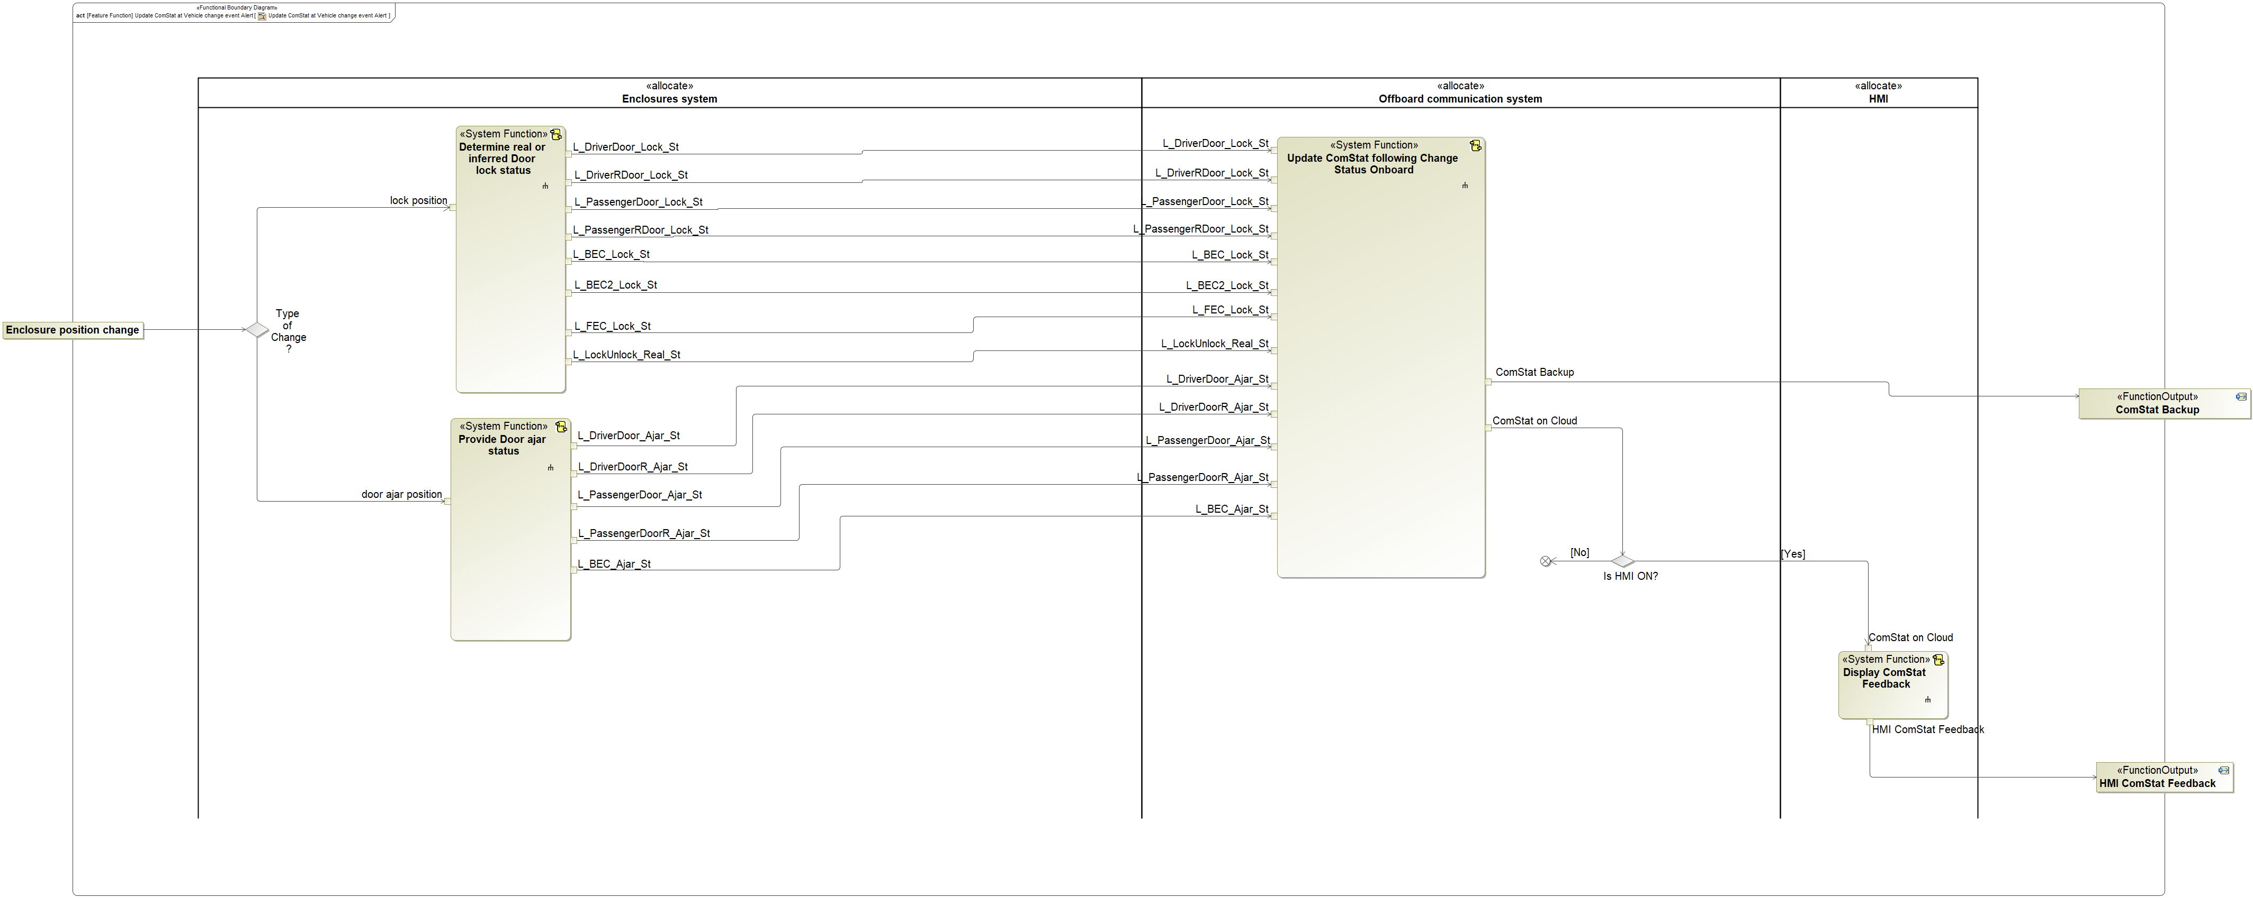

Figure 8: Update ComStat at Vehicle change event Alert

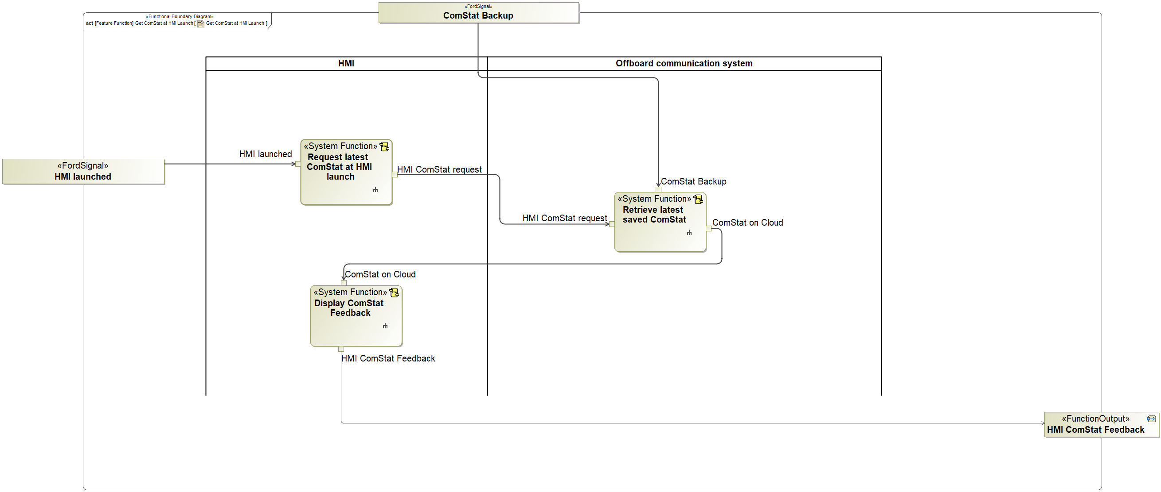

Figure 9: Get ComStat at HMI Launch

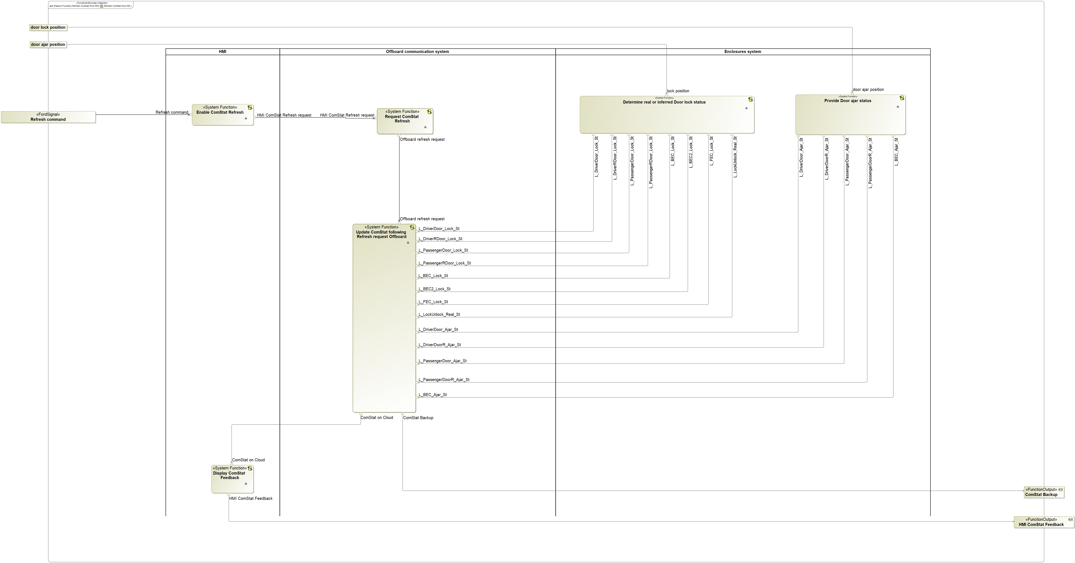

Figure 8: Refresh ComStat from HMI

### Functions

| **Function Name** | Description | Comments |
| --- | --- | --- |
| *(activity)* Update ComStat following Change Status Onboard | Comprehensive Status is updated on Cloud following door lock or ajar status change received from vehicle. |  |
| *(activity)* Determine Real or Inferred Door lock status | Door lock status determined as inferred or real |  |
| *(activity)* Provide Door ajar status | Door ajar status change provided from Vehicle |  |
| *(activity)* Display ComStat Feedback | Comprehensive Status Feedback is received if the App (HMI) is open |  |

Table 16: List of Functions on Update ComStat at Vehicle change event Alert

| **Function Name** | Description | Comments |
| --- | --- | --- |
| *(activity)* Display ComStat Feedback | Comprehensive Status Feedback is received if the App (HMI) is open |  |
| *(activity)* Retrieve latest saved ComStat | Latest Comprehensive Status saved on Cloud is retrieved |  |
| *(activity)* Request latest ComStat at HMI launch | At HMI launch latest Comprehensive Status is requested |  |

Table 17: List of Functions on Get ComStat at HMI Launch

| **Function Name** | Description | Comments |
| --- | --- | --- |
| *(activity)* Update ComStat following Refresh request Offboard | Comprehensive is updated on Cloud following refresh request from Offboard |  |
| *(activity)* Enable ComStat Refresh | Comprehensive Status refresh is requested from HMI |  |
| *(activity)* Request ComStat Refresh | Comprehensive Status refresh request is received by the Vehicle from the Cloud |  |
| *(activity)* Determine Real or Inferred Door lock status | Door lock status determined as inferred or real |  |
| (activity) Provide Door ajar status | Door ajar status provided from Vehicle |  |
| *(activity)* Display ComStat Feedback | Comprehensive Status Feedback is received if the App (HMI) is open |  |

Table 15: List of Functions on Refresh ComStat from HMI

## Logical Architecture

Description of diagram and content on logical architecture in Documentation field of Structural Boundary Diagram.

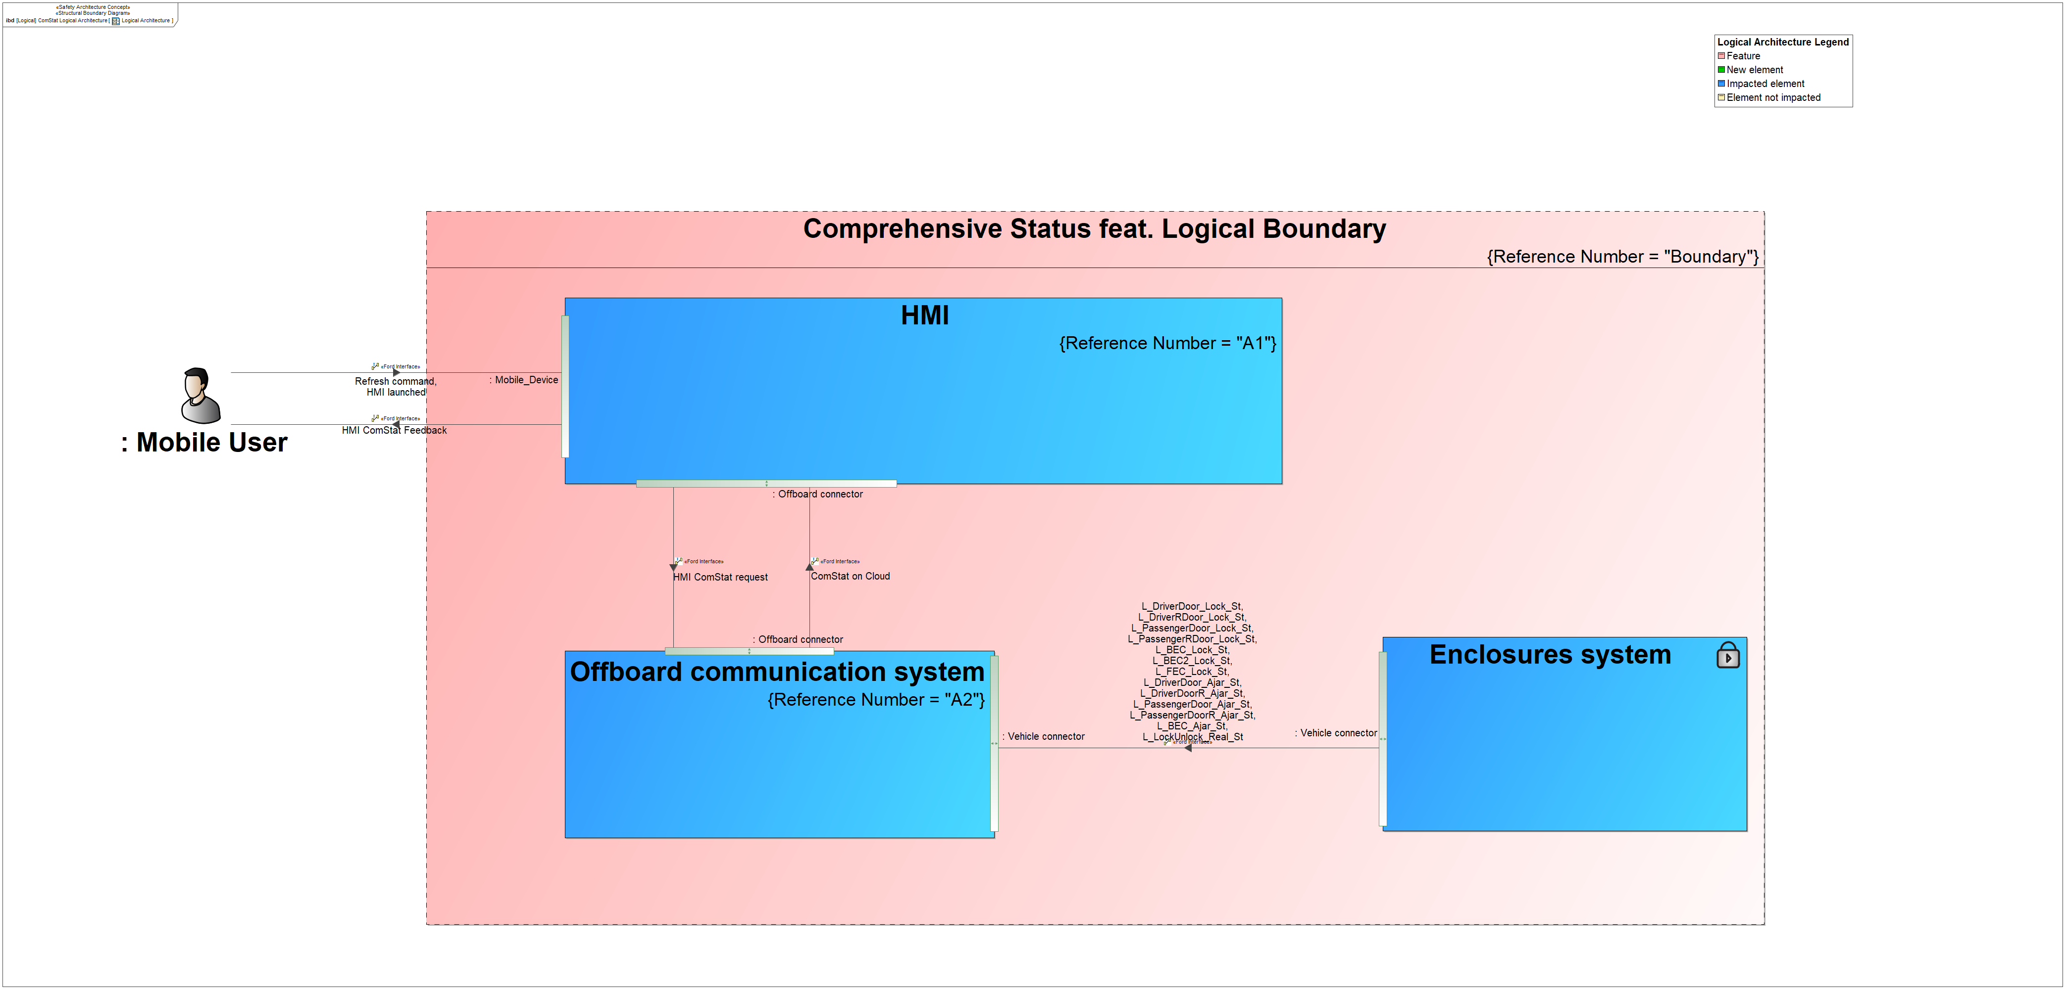

Figure 9: Logical Architecture

### Logical Elements

|  |  |  |  |
| --- | --- | --- | --- |
| **Element Name** | **Description** | **Allocated Functions** | **Comments** |
| HMI | User Interface | * Display ComStat Feedback * Request latest ComStat at HMI launch * Enable ComStat Refresh |  |
| Offboard communication system | System in charge of the vehicle liaison to the Cloud | * Request ComStat Refresh * Update ComStat following Refresh request Offboard * Retrieve latest saved ComStat * Update ComStat following Change Status Onboard |  |
| Enclosures system | System in charge of the doors and other enclosures in the vehicle | * Provide Door ajar status * Determine Real or Inferred Door lock status |  |

Table 16: Logical Elements

### Logical Interfaces

|  |  |  |  |
| --- | --- | --- | --- |
| **Interface** | **Direction** | **Logical Signals** | **Value Range** |
| Mobile Interface | Mobile User to HMI | HMI launched  Refresh command |  |
| Mobile Interface | HMI to Mobile User | HMI ComStat Feedback |  |
| Cloud Interface | HMI to Cloud | HMI ComStat request |  |
| Cloud Interface | Offboard communication system to HMI | ComStat on Cloud |  |
| Vehicle Interface | Enclosures system to Offboard communication system | L_DriverDoor_Ajar_St  L_DriverDoorR_Ajar_St  L_PassengerDoor_Ajar_St  L_PassengerDoorR_Ajar_St  L_BEC_Ajar_St  L_DriverDoor_Lock_St  L_DriverRDoor_Lock_St  L_PassengerDoor_Lock_St  L_PassengerRDoor_Lock_St  L_BEC_Lock_St  L_BEC2_Lock_St  L_FEC_Lock_St  L_LockUnlock_Real_St |  |

Table 17: Feature Interactions

# Traceability Matrix

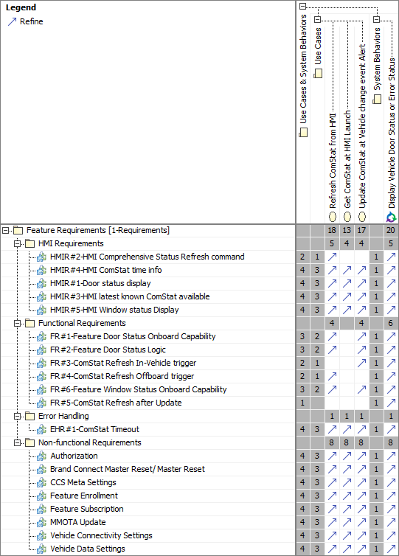

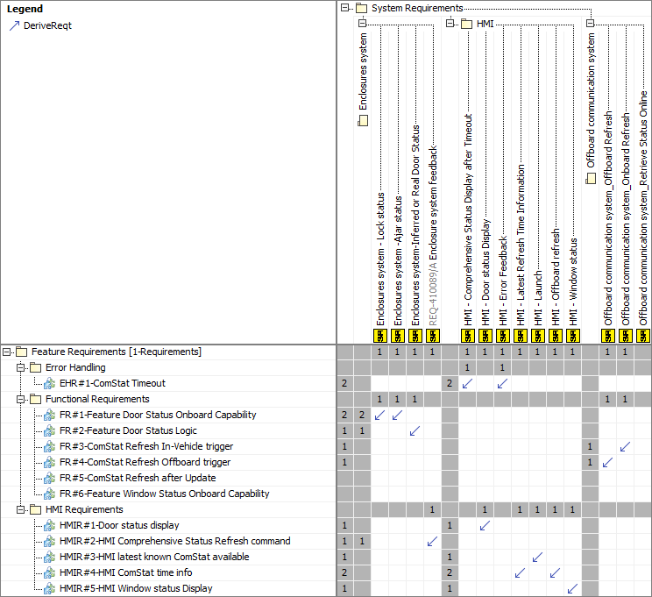

# Open Concerns

| ID | Concern Description | e-Tracker / Reference | Responsible | Status | Solution |
| --- | --- | --- | --- | --- | --- |
| 1 |  |  |  |  |  |

Table 20: Open Concerns *(Not supported by MagicDraw report generation)*

# Revision History

No Revision History found.

# Appendix

## Definitions

| **Definition** | **Description** |
| --- | --- |
| API | Application Program Interface |
| ATT | Advanced Transport Telematics |
| BCM | Body Control Module |
| CAN | Controller Area Network |
| CCS | Customer Connectivity Setting |
| ComStat | Comprehensive Status |
| ComStat feat. | Comprehensive Status feature |
| DFMEA | Design - Failure Modes and Effects Analysis |
| DRX | Discontinuous Reception |
| ECG | Enhanced Central Gateway |
| EDS | Electrical Distribution System |
| feat. | Abbreviation used for feature |
| FMA | Failure Modes Analysis |
| FTCP | Ford Telematics Communication Protocol |
| High speed | Approximately more than 52 mph (83 kph) |
| IoT | Internet of Things |
| LF | Left Front |
| LIN | Local Interconnect Network |
| Low speed | Approximately 12 to 36 mph (19 to 58 kph ) |
| Medium speed | Approximately 36 mph to 52 mph (58 to 83 kph) |
| MQTT | Message Queuing Telemetry Transport |
| RHCD | Rear Hinge Cargo Door |
| SoC | State of Charge |
| TCU | Telematics Control Unit |
| term | A representation of a Concept expressed in Natural Language. In the vocabulary of a Domain of Discourse a term enables common understanding of domain concepts. |
| term glossary | A term glossary is a table of agreed upon definitions for terms used in project development that may provide clarity or avoid confusion to stakeholders. |
| TLA | Three Letter Acronym |
| TMC | Transport Mobility Cloud |
| Very Low Speed | Approximately 0 to 12 mph (0 to 19 kph) |
| VSDN | Vehicle Service Delivery Network |

Table 21: Definitions used in this document

Document ends here.